Meta Title:
Professional Logo Design Services Agency in Dubai
Meta Description:
Need professional and creative logo design services in Dubai? Meet TAM, the leading logo designing company in Dubai to get an engaging logo for your brand.
Keyword | Volume | Keyword Difficulty
logo design | 6600 | 80
Logo Designing Company in Dubai | 720
company logo design | 720 | 81
logo design company | 720
logo design company Dubai | 720 | 31
logo design Dubai | 720 | 36
logo design online | 480 | 84
best logo design | 260 | 78
3d logo design | 110 | 48
creative logo design | 110 | 59
new company logo design | 110 | 83
logo design agency | 90 | 23
custom logo design | 20
Logo designers in Dubai | 10
logo design services | 10

Get Personalized Logo Designs Exclusive For Your Dubai Brand
At Three Angle Marketing, we not only design logos but build visual identities for brands through creative, unique, strategically crafted logo designs. Our team is composed of competent and creative logo designers capable of offering customized logo design services to meet the diverse requirements of our clients.

Get A Free Quote!

The Importance of an Impressive Logo Design: A Multi-Dimensional Approach
In the highly competitive environment of Dubai, the importance of developing a logo that will appeal to your target audience cannot be overstated. At Three Angle Marketing, the leading Logo Designing Company in Dubai, we implement effective methodologies while offering unique, flexible, versatile, and technical logo design services.

Thoroughly Original | Adaptable & Versatile: | Technically Sound
Our company logo designs are attractive and creative allowing your brand to stand out from those of your competitors and be easily identifiable. | We design logos that are flexible and practical, suitable for any platform, and complement any kind of branding requirements a company may have. | The logo designs that our logo design company creates are not only great looking but they are well coded and constructed for both print, website, and other platforms.
More Than a Logo | Clarity and Simplicity | Memorability and Impactfulness
Our logo design company in Dubai not only designs logos but also provides branding services appropriate to the nature, purpose, and goals of your business. | Our logos are well crafted and straightforward to enable your target group to understand and possibly associate your brand with the logo easily. | The logos that our logo design Dubai company crafts are going to make some kind of impact on your customers, something that will remain in their minds.

Revolutionize Your Business in the UAE With a Professional Logo Design Agency:
Three Angle Marketing (TAM) is the #ONE creative logo design company in Dubai specializing in providing high-quality 2D/3D logo designs for companies operating in the UAE. Our professional and qualified logo designers stay in touch to make sure that your company gets a unique and easily recognizable logo design relevant to your market niche.
Our vision is to help you turn your business into a ‘brand’ that communicates and makes your presence felt in the highly fluid market of the UAE. At our logo design agency, our designers work hard to ensure that your brand logo is unique, professional, and appropriately creative to get the desired visibility for your business.

Talk to A Logo Expert

The Difference We Deliver:
At Three Angle Marketing, we offer the best logo design services that can produce the highest level of satisfaction for our clients. Our streamlined process includes:

Communication & Research | Design Brief | Brainstorming Ideas
This involves communication to ascertain our client’s goals, target niche, and product or service features within the chosen market. | We develop a clear design brief that captures the aspects of the brand identity that need to be handled by the logo design. | By taking different perspectives into consideration, our creative team works together with your input to devise myriad creative possibilities.
Selection & Fine-Tuning | Presentation & Feedback | Delivery & Applications
Our expert designers choose and show you the final logo samples, considering your requests and choosing the best logos for you. | The final logo designs are displayed and we welcome your invaluable suggestions so that satisfaction can be achieved. | Once the final logo is approved for implementation we provide it in multiple formats and usage to your brand’s marketing department.

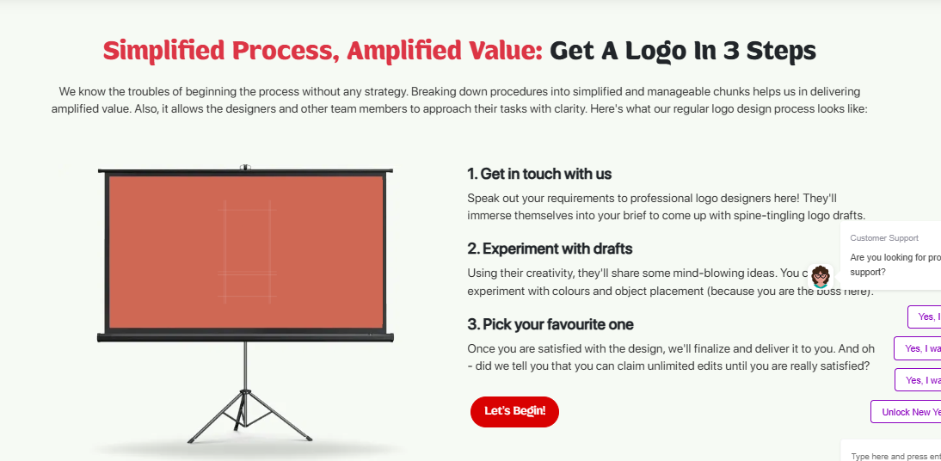

Our Streamline Process: Get Your Logo in 3 Easy Steps
TAM Logo designers in Dubai understand very well about the intricacies of the logo design process. Moreover, our designers also understand very well the thoughts, and inspirations, and shape ideas to convert an idea into reality. This is our 3 step process:

Get In Touch | Sketching & Conceptualization | Presentation & Approval
We consider your brand requirements and the details required for the complete information to consider your brand and your vision. | We make your brief our starting point to provide a wide array of expertly and exclusively created logo designs based on your business. | We display the designed logos to you and you pick your favorite or request changes to be made. Upon final design, we submit it to you in different forms.

Turn My Vision Into Logo

Ready to Redefine Your Brand With Premier Custom Logo Design Agency:
Join forces with Three Angle Marketing (TAM) and tune into our expertise to help you design an engaging logo that embodies your company’s spirit. Welcome the chance to revamp your brand identity and earn a worthy place in the saturated market of the UAE with our efficient new company logo design services.

FAQ’s
Given below is the answer to your listed concern.

What is the standard logo dimension? Will I be able to resize it?
All our logos are created in a vector style so you can adjust them to the size and quality you want with ease. The dimension of a logo that is used in most printed materials is usually 2 inches wide. In case you are working with digital platforms, our experts will reduce or enlarge the size of the logo to fit your brand preferences.

What other services do you provide apart from logo design services?
Apart from offering logo designing services, Three Angle Marketing also offers different related graphic design services such as brand identity, business cards, brochures, banners, and web designing.

Do I acquire the copyrights to your designed logo?
Yes, once you pay for the needed logo, all the rights to use and refine the approved logo belong only to you. You will receive the logo in .AI .EPS .PDF and .JPG formats to be used on all the platforms.

Does TAM offer editing or revising services for the logo design?
Yes, At Three Angle Marketing, we offer full revising or editing until our clients are fully satisfied with the designed logo. The goal of all our designs is to ensure that you are utterly satisfied with the final product, and we will only release the logo once it provides full satisfaction.

What makes TAM logo design service different from the rest of the competitors?
We differentiate ourselves on the basis of our designers who are experienced and equipped with the required resources. Moreover, we take our clients individually and understand their branding needs in a much better way. Apart from that, we offer extra services such as revisions and support in case you want the best logo design for your business.

Will you provide the initial design concepts for my logo?
Yes, indeed, we will offer you many different initial design ideas for you to select from. Moreover, we will assist you in fine-tuning logo designs by adhering to your brand requirements.

What do I get once the logo has been approved and paid for?
After the approval of the logo and the payment has been made, you will be provided with the logo in different formats such as AI, EPS, PDF, and JPG. You will also be free to own the logo design for its use and change it once in a while as it suits you.

What graphic and logo designing software or tools do you use?
We have skilled designers who work with standard design tools such as Illustrator, Photoshop, and Corel Draw among others to produce excellent logos and business designs.

